Name: [Ghulam Mustafa]
Email: mustafabrohi874@gmail.com
Overview:
This file contains information about 3 US stocks, evaluating market trends, prices, P/E ratio and recent news.
TASK 1

Analysis of Nvidia, Apple inc, and Microsoft
This report contains information about 3 key US stocks, Nvidia, Apple, and Microsoft. Evaluating the prices, market cap, recent news, and performance.
- Nvidia corporation
Nvidia corp is an American technology company established in 1993 by Jensen Huang, Chris Malachowsky, and Curtis Priem. The company is currently located in Santa Clara, California, United states, the main focuse of the company is making GPUs and recently in artificial intelligence (AI).
- Apple inc
Apple inc is an American multinational technology company, founded in 1976 as Apple Computer Company by Steve Jobs, Steve Wozniak and Ronald Wayne. The company is currently headquartered in Cupertino, California, United States. The company is best known for its consumer electronics, software and online services.
- Microsoft corporation
Microsoft corp is an American multinational technology, was founded in 1975 by Bill Gates and Paul Allen. The company become famous with personal computers through software as Windows.
The above bar chart shows the current market capitalization of the companies, Nvidia, Apple and Microsoft.
Apple has the highest value among, representing strong market cap, and investing confidence.
Nvidia Corporation
Nvidia is one largest tech companies in the U.S. It designs GPUs and advanced computing, and nowadays famous for artificial intelligence (AI) structures.
Due to rising AI chip demand, Nvidia has seen significant growth in revenue, market value, and investor interest.
- Recent News on Nvidia as of February, 2026
Analysts note Nvidia dominates GPU and AI chip markets. Reports suggest Nvidia could be a major winner as AI spending rises. Nvidia is close to investing $20 billion in OpenAI's funding round, showing its AI ecosystem involvement. Despite strong collaboration, OpenAI is exploring alternative AI chips, (Google finance).
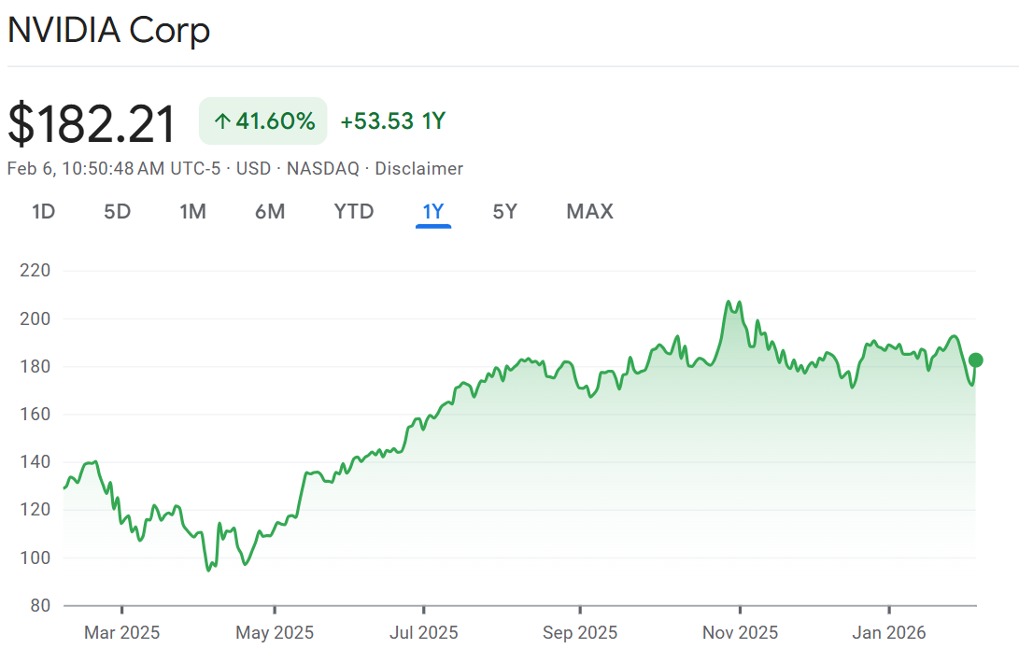
- Price trend
The chart shows Nvidia’s price trends from February 2025 to February 2026. Price is $140 per share, stable in early February 2025, but drops suddenly in March 2025. Shares fluctuate between $110 and $120, and in April 2025, prices fall to $97, causing tension.
Nvidia experiences a bullish moment in May 2025, with prices rising to $180 per share.
The peak occurs in October and November, with prices increasing from $180 to $207, marking another bullish moment.
In summary, Nvidia's performance was notably strong last year, reflecting growth in artificial intelligence (AI) as interest increased(Google finance).
- PE Ratio
Price-to-Earning ratio (P/E) ratio measures how much investors are willing to pay for each dollar of a company’s earnings.
Nvidia’s P/E ratio is 45.92% currently (February 2026), which is relatively high and indicates that investors are willing to pay a higher price for Nvidia’s earnings.

Apple
Apple is one of the famous and largest consumer electronics, software and services company. Which is famous for its major products as iPhone, iPad, Mac and Apple watch.
Apple has strong global brand, loyal customers and diverse revenue, making it stand out and mature company in tech sector.
- Recent News, as of February 2026.
Apple recently announced to open its first Educational Hub in India. The hub will be located in Bangaluru with collaboration of Manipal Academy of Higher Education. (Source)
Apple announced its financial results of the first quarter of 2026, achieving revenue of $143.8 billion, a 16% year-over-year growth. Service revenue hit $30 billion, 14% increase from previous year and a 0.72 increase in stocks.(Source)
- Price Trend
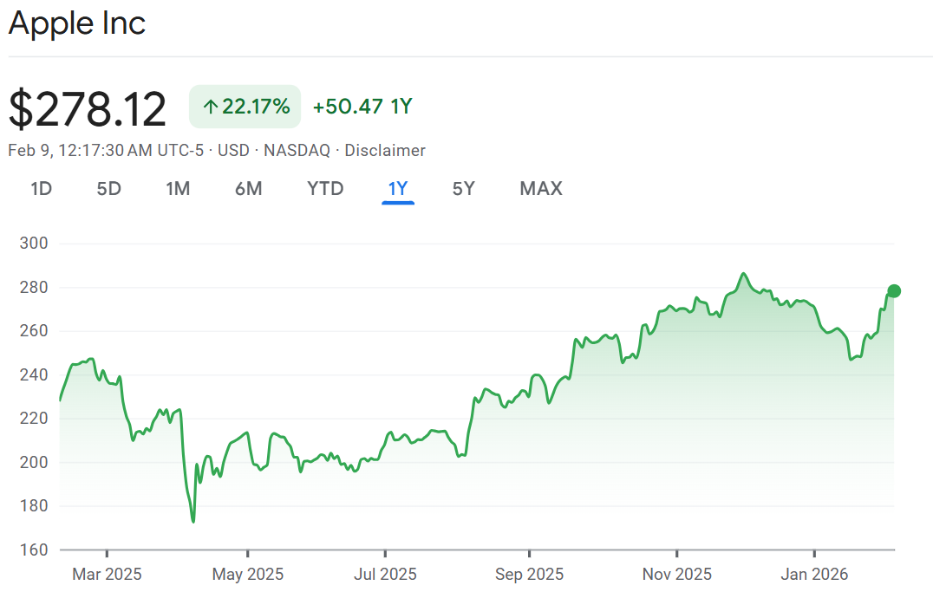
The above chart is as of February 2025 to February 2026 showing Apple’s performance and price trend. During the February 2025, the price of the stock ranges between $230 to $240, and suddenly drops in March from $239 to $215. The prices fluctuate around $215 to $220, in April the prices go down again, hitting $170, which is bearish for 2nd time. The Apple witnesses bullish in May reaching $200. Overall, Apple’s stock prices fluctuated around $200 to $250, but during October and December, they hit $286 with Volume of 44M.
- PE ratio
The profit and earning PE ratio of Apple is 35.19% currently as of February 2026. Which is high showing investor interest and high pay for per dollar.
Microsoft
Microsoft Corporation plays an important role in technology, artificial intelligence and enterprises. It’s a global technology company, offering Windows, Microsoft Office, and LinkedIn.Which makes it one the stable and influential companies in tech sector.
- Recent News
Recent news for Microsoft highlights market reactions to its AI and cloud spending. Investors have been cautious as the company posted record capital expenditures for AI infrastructure and cloud revenue growth that slightly missed expectations, causing periods of share price weakness. Analysts have noted the stock’s volatility, with some recommending long-term holding despite short-term pressure. These developments reflect ongoing investor concerns about balancing heavy AI investments with consistent financial returns — even as Microsoft remains a key player in cloud and AI technology(Source).
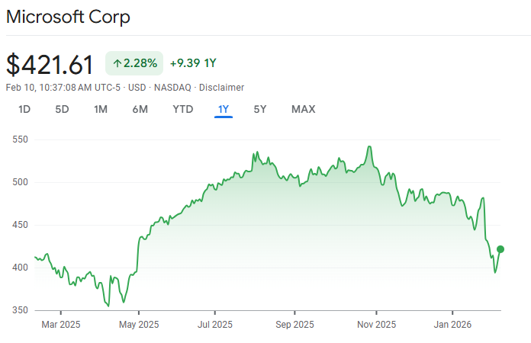
- Price Trend
The above chart shows Microsoft’s stock price trend from February 2025 to February 2026. During early 2025, the stock traded between $380 and $410, followed by a gradual decline in March and April. From May 2025, Microsoft experienced a strong bullish trend, with prices rising steadily and peaking above $530 during October and November 2025. However, towards the end of 2025 and early 2026, the stock declined and traded around $420, reflecting market correction and increased volatility.
- PE ratio
Profit and Earning ratio of Microsoft is 25.53% currently, which indicates good performance and high pay for per dollar.
Comparison

In conclusion, the companies Apple, Nvidia and Microsoft are one of the largest tech companies, which are famous for their own services and products offered. And the report shows that the companies hold strong positions in the market, backed by innovation, technological leadership and long-term growth.
In simple words, the performance of the stocks indicating a strong confidence and sustained growth in their future, especially in areas as artificial intelligence, cloud computing and consumer technology.

